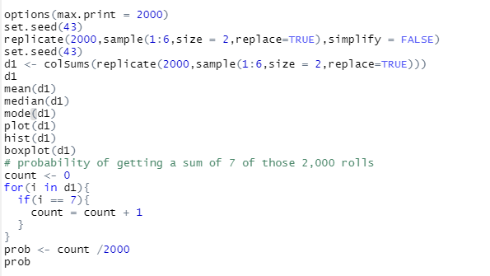

random rolling of two-dies for 2,000 times, I use function *replicate()*  for random two face value which is from 1 to 6 and use this function to repeat this work 2000 times, and I use *simplify* argument and set it FALSE to display value list not matrix or array for easy to read to two face value. Max print in Rstudio is about 1000 times and I must to set max print equal 2000 by use *options(max.print =2000)*

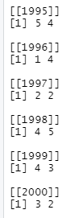

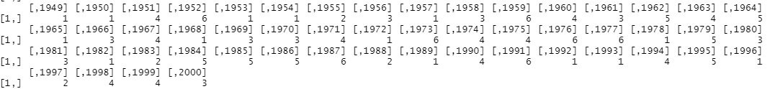Picture 1 : set simplify = FALSE

Picture 2 : set simplify = TRUE

(this picture has just 1 row that I highlight in picture 1)

I’m set seed to 43 just for getting the same value every time that I run. A sum of the two face values, I use function *colSums()* this function is not supported list value and I must be delete simplify = FALSE.

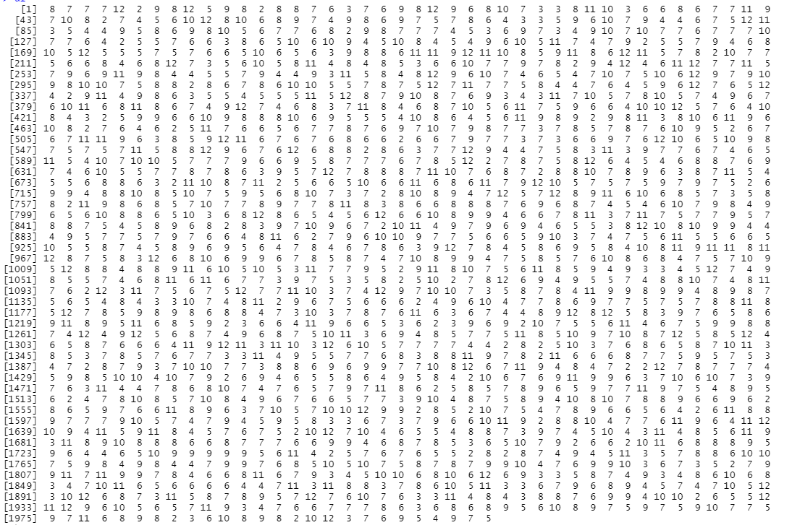

Picture 3 : sum of two face value for 2000 times

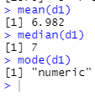

Statistic value(mean, median) and mode(type of this vector)

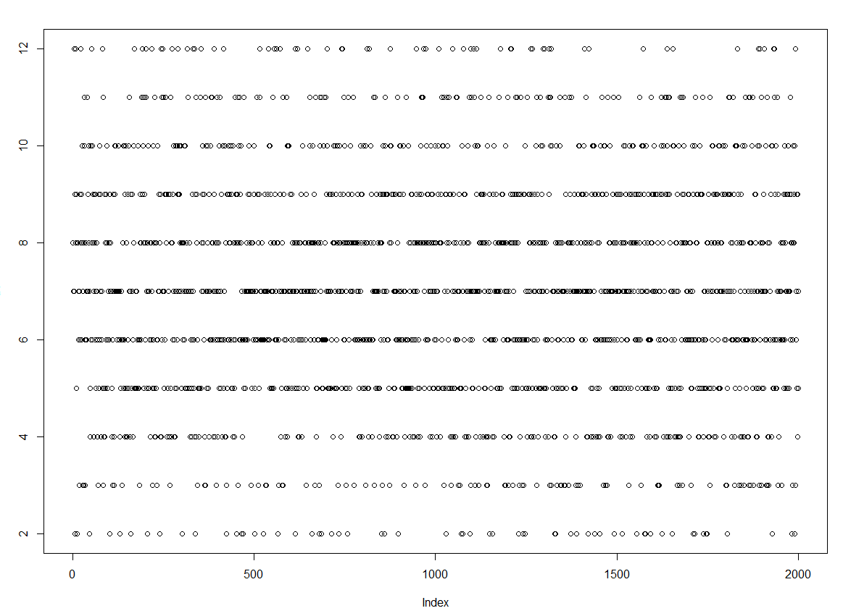

Picture 4: plot

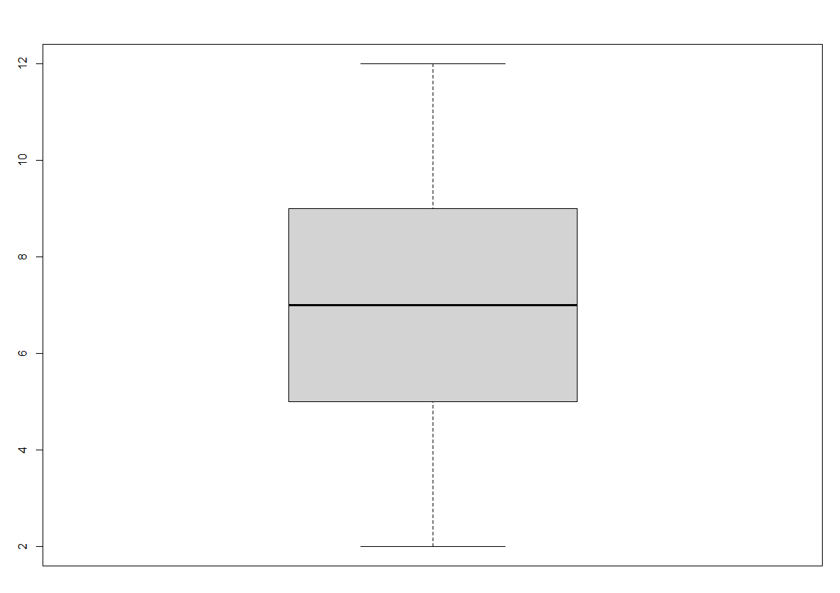

Picture 5: box plot

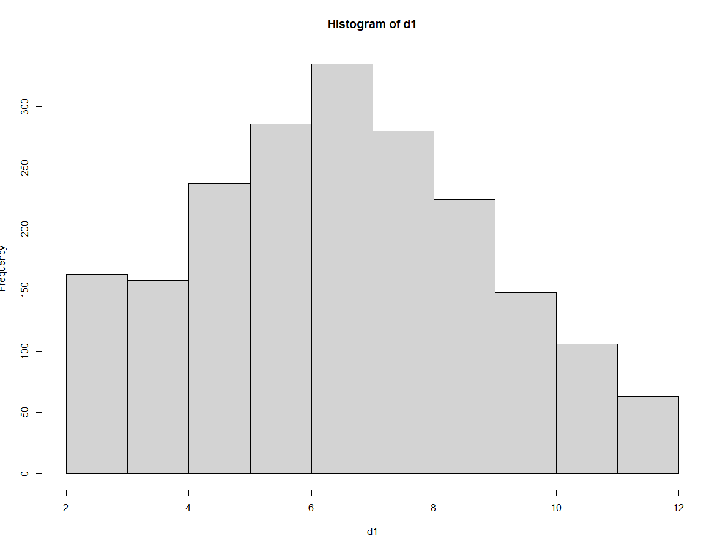

Picture 6: simple histogram

find a probability of getting a sum of 7 of those 2,000 rolls. -> I use *for loop* to find it. If statement help me to find sum = 7 from all value. When find sum = 7 then count it, finally bring *count* value divided to 2000(amount times to roll two dices)



Picture 7: probability value